PRESS RELEASE
September 20, 2022

Unique wind farm collaboration:
Elcowire takes the lead in the decarbonisation of copper

In a revolutionary step for the industry, Swedish copper solutions company Elcowire with their power cable customer NKT are to deliver Low-carbon Copper-based cable systems for power export from the third phase of the world’s largest offshore wind farm project, Dogger Bank C, off the north-east coast of England. The lowered emissions, thanks to using Low-carbon Copper is estimated to over 23,000 tons of CO₂, equivalent to 7,700 average gasoline-powered family cars driven for 1 year.

“As Northern Europe’s leading provider of copper wire products,” says Paul Gustavsson, CEO Elcowire Group, “this unique collaboration with our customer NKT in the Dogger Bank C phase marks another successful step forward for Elcowire and for our commitment toward low-carbon solutions, which we have worked on together with our partner Boliden. We are extremely proud to be involved in this impressive project. To us, it is a breakthrough for the sustainable Low-carbon Copper material. It looks like it will become the inevitable choice in energy infrastructure for the future.”
NKT’s President & CEO Alexander Kara, comments: “We have started collaboration with our suppliers and customers to reduce our carbon footprint throughout the value chain. The cooperation with our suppliers enables us to produce even more sustainable cables using their Low-carbon Copper in our factories that are powered by renewable energy. I am pleased that we have set up this collaboration, so we can continue contributing to connecting a greener world. This will ultimately help us meet our sustainability commitments, including becoming a net-zero emission company.”

As a result of Elcowire’s commitment to support the global shift toward sustainable raw materials, the company has managed to produce and market Low-carbon Copper solutions with less than half the carbon footprint of standard copper-rod as well as other products. This is an accomplishment made in close cooperation with metal company Boliden, who processes the raw copper from ore sourced from Swedish mines.
Paul Gustavsson highlights that the reduced CO₂ emissions of Elcowire’s Low-carbon Copper products have been validated scientifically and will help customers to achieve their supply chain related emission reduction targets faster and more efficiently.
In fact, in the example of Dogger Bank C, the low-carbon solution combines efforts from three Scandinavian companies. The copper decarbonisation starts already in the metal company Boliden mine to continue through Elcowire’s copper wire production and further on to NKT’s high voltage power cable manufacturing. Boliden relies on a very efficient ore concentration process and a world-class green energy mix. Elcowire is supplied with the incoming material by electrified railway, and in very efficient processes then produces the Low-carbon Copper wires. And power cable solutions company NKT completes the picture with their final contribution, using renewable electricity in the production and the advanced, fuel-efficient cable-laying vessel NKT Victoria.

The aggregate Low-carbon Copper footprint accomplished in this unique collaboration eventually benefits the end customer, the Dogger Bank wind farm, phase C, developed as a joint venture by Equinor, SSE Renewables and Eni Plenitude, as well as tomorrow’s European energy consumers. It is a very important step toward the net zero vision for carbon emissions in the European society.

For more information, please contact:
Paul Gustavsson
CEO Elcowire Group
+46(0)72-555 29 00
paul.gustavsson@elcowire.com

About Elcowire Group:
Elcowire is one of the leading suppliers in Europe of products and services based on copper and aluminum wire rod for the electrical and infrastructure industry. Operations are located in Sweden and Germany. Elcowire consists of five business units: Rod, Wire & Strands, Rail, High Voltage and Specials. The company has 400 employees and headquarters are located in Helsingborg, Sweden. More information at www.elcowire.com

About Liljedahl Group:
Liljedahl Group is a family-owned corporate group with seven wholly-owned holdings: Elcowire Group, Dahrén Group, Hörle Wire Group, Pronect, Finnvedens Lastvagnar, Finnvedens Bil and Liljedahl Group Fastigheter. Liljedahl Group is also principal owner of Bufab AB (publ). The Group has an annual sale of approximately SEK 15 billion and 1,500 employees globally. More information at www.liljedahlgroup.com

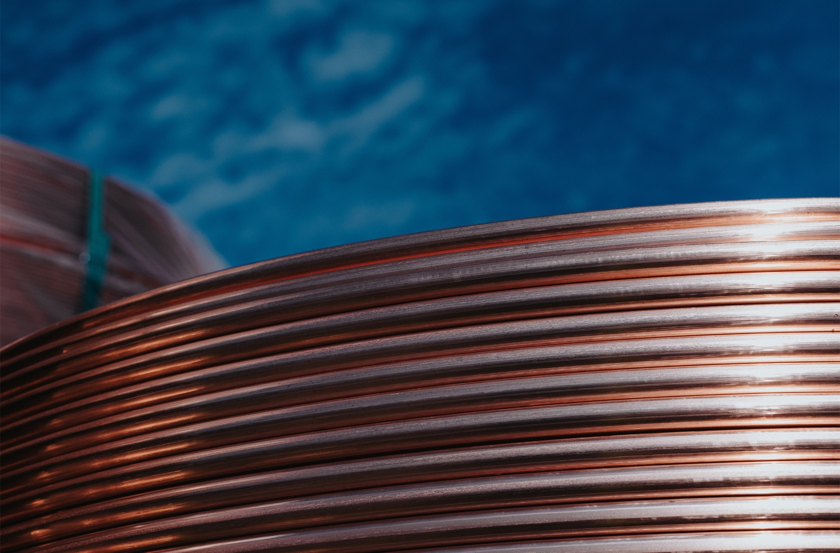
Image ©Elcowire Group: Copper wire rod

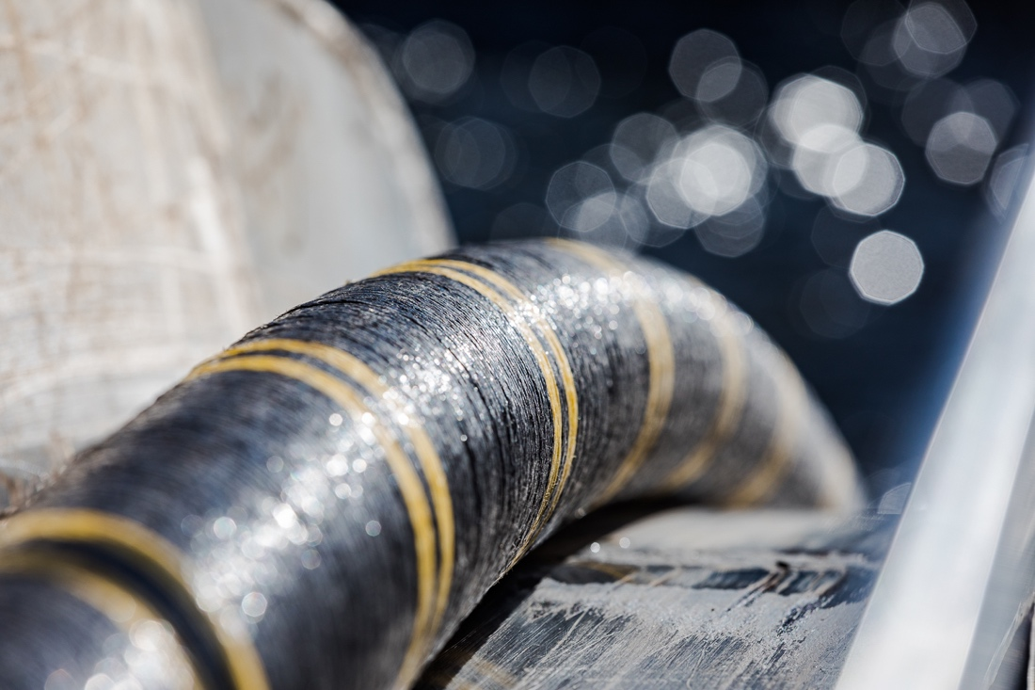
Image: ©NKT: Cable being placed on seabed
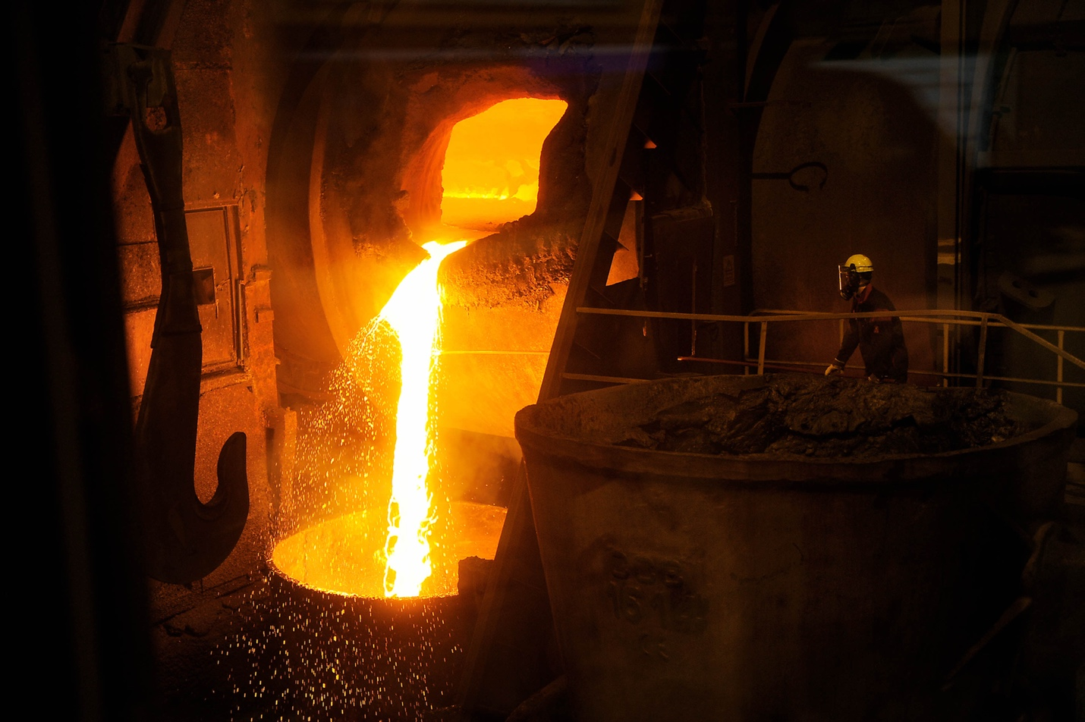
Image ©Boliden: Melting virgin copper in furnace

